Jennifer Stegina

13 September 2019

CIS 250

**Unit 3 Graded Exercise 4**

The following questions come from the “Check your understanding” examples of each section of Chapter 11 & 12 in your textbook.

After you are finished, please submit a Microsoft Word file that contains screenshots of the SQL Queries, the output, and put a comment line in the query with your last name. Your document should be named **U3_GuidedPractice4_Lastname.docx**.

(11-3) Question 1:

Table *sec1103* contains two columns, *row_ID* and *num_1*. (It also contains a column named *num_2*, but we are not going to use that column now.) Find the minimum and maximum values of the *num_1* column. Name these values “minimum” and “maximum.”

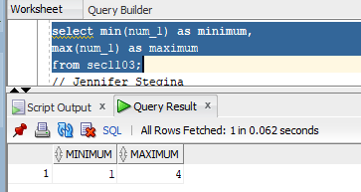

(11-4) Question 2:

Repeat the exercise in the previous section, except this time add a *where* clause that limits the *row_ID* column to values less than 8. Is there any change in the minimum and maximum values?

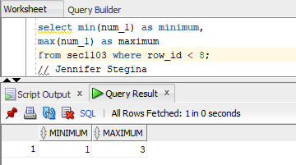

(11-6) Question 3:

In table *sec1106*, find the following information:

■ The number of rows in the table

■ The number of rows that have a non-null value in the *Num_1* column

■ The number of rows that have a null value in the *Num_1* column

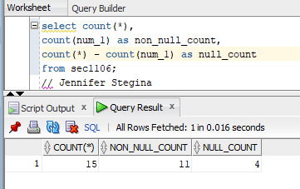

(11-9) Question 4:

In table *sec1103*, find the number of distinct values in the *num_1* and *num_2* columns, taken together.

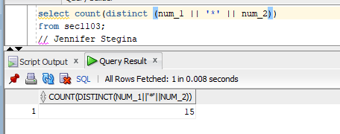

(11-11) Question 5:

In table *sec1103*, show the problem with nulls in addition and how to solve it.

1. Add columns *num_1* and *num_2*, adding each row first.

2. Add columns *num_1* and *num_2*, adding each column first.

3. Add columns *num_1* and *num_2*, changing all the nulls to zeros first.

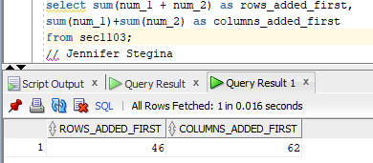

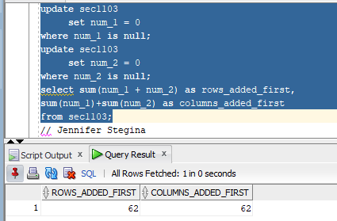

(12-2) Question 6:

Table *sec1202* has four columns: *row_id, col_1, col_2,* and *col_3*. Write a select statement that groups the rows by the value in *col_1* and for each group determines the sum of the values in *col_3*.

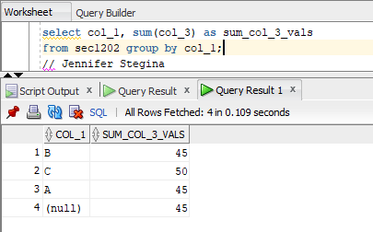

(12-4) Question 7:

Use table *sec1202*. Write a select statement that groups the rows by the value in *col_1* and *col_2*. For each group determine the sum of the values in *col_3*.

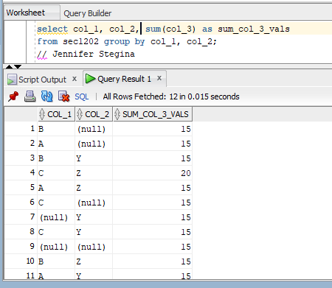

(12-7) Question 8:

Suppose you wanted to show all the data in table *sec1202* and you also wanted to show the total for *col_3*. Could you do this with SQL?

The answer is no. The best you can do is to run two queries. One would show the data with:

*select \**

from *sec1202;*

The other would show the total with:

select *sum(col_3)* as *grand_total*

from *sec1202;*

Then, if you were desperate, you could paste the two pieces of paper together. Or you could do the same thing in SQL using a union.

Fortunately, most SQL products give you a better way. There is usually some sort of report level to the software that will do totals and subtotals for you.

(11-11) Question 9:

Table *sec1211* has three columns: *row_id,* *col_1*, and *col_2*. Group on *col_1* and get the sum of *col_2*. Add a having clause to show only the rows of the result table where the sum is greater than 20.

